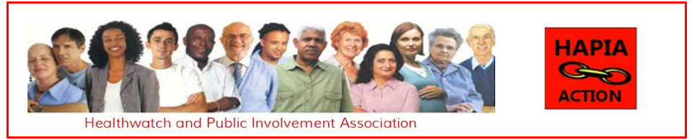

MINUTES OF THE ANNUAL GENERAL MEETING
Monday, 13 November 2023

IN ATTENDANCE

Malcolm Alexander – Chair | Alan Alexander
Polly Healy | Robin Kensley
Mary Ledgard | Saleem Siddiqui
Sister Josephine Udie | Cynthia White

- To be RESOLVED that the Report and Financial Statements of the Company for the year ended 31 December 2022 be and is hereby received and adopted by the Meeting.
Unanimous Agreement

- To be RESOLVED that Malcolm Ben Alexander, as a Director retiring by rotation in pursuance of the Company’s Articles of Association, and being eligible for re-election, be and is hereby re-elected as a Director of the Company.
Unanimous Agreement

QUESTIONS AND ANSWERS
Cynthia White (Chair, Older People’s Reference Group - OPRG) – The Group is considering its topic for its Open Meeting in December. I wonder the topic might commend itself to this Organisation in that we take exception to what we have learned through the evidence presented to the COVID Inquiry that ill-health (with the upper age groups), is apparently regarded as the Nations way of dealing with older people and, by inference, not to be resisted.
Having watched the Covid Inquiry evidence on the early days, and being quite appalled at that stance – whilst wanting equity and justice for all patients of all ages – I have to draw the conclusion that the protected characteristic, which is legally required for older people, amongst others, no longer pertains.
I think that is a discussion point which is worth raising by any organisation involved with health.
We are discussing (on Wednesday – 15 November 2023) the Theme and Speakers for the Open Meeting that will take place in early December and, at the moment, we have quite a lot of interest along the lines that I have just described.

Malcolm Alexander – What I suggest is that you make contact with Covid Action. They will be thinking exactly along the lines that you have just described. I shall put you in contact with Joseph Healy, who is one of the leaders of Covid Action.
Covid Action is a very effective and assertive organisation and would be a good organisation for OPRG to link up with.

Cynthia White – Thank you. At the meeting on Wednesday, I shall mention your suggestion and get our Administrator to take this up.

Mary Ledgard – Can we have clarification about the OPRG?

Cynthia White – I have been Chairing the City and Hackney OPRG since 2007. The Group is funded by the Clinical Commissioning Group (CCG) now known as the NHS NEL CCG.
We are a Reference Group – self-determining – of about 450 older people (over 50 years of age) and resident in City and Hackney over 50 years of age.
We have a particular focus (but not an exclusive one), on health issues affecting older people, and the context of those issues, and Policy, and the connecting with Social Care provision.
We have Open Meetings and Newsletters circulated and an electronic Newsletter going out about 3-4 weeks. I would be interested in knowing of anybody who would like to join OPRG or receive our Newsletters as we have a big Agenda. The issues are enormous.

Mary Legard – This is interesting, as this is what I am trying to do in Norfolk.
_______________________________________________________________
Malcolm Alexander highlighted that Mary Ledgard has written a very interesting book on Patient and Public Involvement in Health and Social Care – An Introduction to Theory and Practice.

The Meeting was then closed by Malcolm Alexander

ACTION
- MA to put Cynthia White into contact with Joseph Healy at Covid Action.

