Healthwatch and Public Involvement Association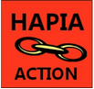
8/4/20

David Amos,
Interim Director of People and Organisational Development
Barking, Havering and Redbridge University Hospitals NHS Trust
Queen’s Hospital,
Romford, Essex, RM7 OAG
david.amos@nhs.net

Dear David,
Further Concerns regarding C-19 at BHR NHS Trust
I am writing to follow up the letter that I sent to Tony Chambers on April 3rd and his response on April 5th. As you know he directed me to you.

The serious alerts we have from your staff, impact on the work that hospital staff are doing to care for Covid-19 patients. We are aware of the extent to which your hospital is affected by the pandemic.

Many staff are feeling very stressed and are finding it difficult to work. They are of course concerned about the impact of their absence from work on patients, but also over their personal health, the health of their families, the adequacy of protective equipment, and the need for effective training to reduce infection risk. It is imperative that the leadership of the Trust recognises this and sends out powerful messages to all staff to reassure and support them. The webinar that I suggested made by GSTT has had a strong and positive impact on staff.

Tony did tell me that: “Taking the best care of the carers who care for our patients is the only way to get through this difficult time and we have in place a whole host of initiatives to achieve this”.

However, we continue to receive messages of great anxiety from some staff about the Trust leadership, in relation to their support for staff who are dealing with C-19 patient cohorts.

The issues raised in my letter to Tony are repeated below. I don’t need a detailed response at this stage – I know you have a great many pressures and priorities right now, but some indicators of how you will quickly achieve best practice in relation to the seven issues below would be greatly valued by staff:

1) That following the death of Thomas Harvey, that there has not been adequate action to protect staff in the BHR NHS Trust, from the risk of harm and death associated with Corona virus infection.
www.ilfordrecorder.co.uk/news/health/nurse-dies-of-suspected-covid-19-1-6587770

2) Nursing staff feel unsupported and are being given conflicting information about safety measures to protect patients and staff, and do not have the right equipment. They told me that staff have had short teaching session on PPE, in some cases post-exposure and that the training was not adequate to ensure that nursing staff were clear about their roles and best practice. Many staff have been transferred to unfamiliar wards after working in non-ward environments for many years.

3) Some staff feel very angry that they have to go off sick in order to protect themselves and their families, because they do not have the right support and equipment. They also report poor support from senior nursing staff.

4) Many nursing staff are particularly concerned that they are at greater risk themselves because pre-existing conditions, and are often caring for vulnerable people at home who have high level disabilities and critical health conditions. They don’t want to withdraw from their nursing duties, but feel they are being given no choice in some cases.

5) There is no adequate risk assessment process to determine which staff should work on which wards, e.g. in relation to their age, chronic illness and other vulnerabilities. This is particularly critical in wards that have too few side-rooms to contain infected patients.

6) The current nursing leadership is sometimes antagonising staff, through apparent insensitivity to the needs of staff, i.e. staff do not feel listened to. This includes staff who have worked in the Trust for many years.

7) When staff return to work after being off sick with Covid-19 symptoms, there is inadequate assessment of their condition, and of support and action to ensure their safety and the safety of patients. This includes a paucity of viral testing.

I would be very grateful if you could ask your colleagues to urgently review these issues and to make an urgent statement to all staff about the action you will take to address these critical concerns.

An example of best practice in relation to Covid-19 communication with staff is available from Guy’s and St Thomas’ Hospital (Anita.Knowles@gstt.nhs.uk) and I would strongly recommend having sight of it.

Very best wishes and thanks.
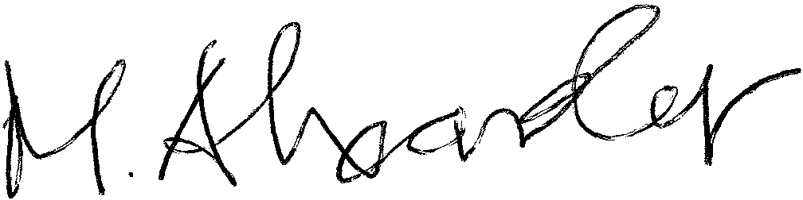
Malcolm Alexander
Chair
Healthwatch and Public Involvement Association.
HAPIA2013@AOL.COM
07817505193

